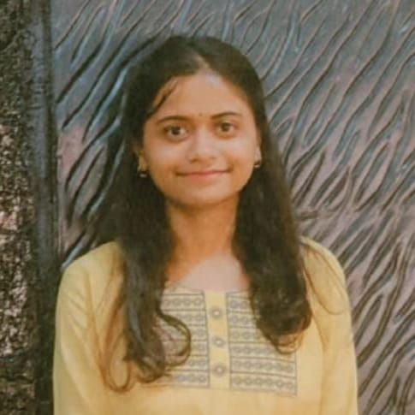
Drishti Priyadarshini
drishtipriyadarshini110@gmail.com | LinkedIn| | GitHub
+91 8789932950 | Muzaffarpur , Bihar , 842001

Personal Summary
Analytically driven professional with a strong foundation in computer science and a passion for using data to derive meaningful insights. Experienced in leveraging programming languages and data analysis tools to solve complex problems. Committed to continuous learning and growth in a dynamic and challenging environment.

Skills
- Programming Languages: C, Java, Python
- Data Analysis & Visualization: SQL, Pandas, NumPy, Matplotlib.
- Web Development: HTML, CSS, JavaScript
- Tools & Technologies: AWS, MS Excel
- Coursework: Database Management Systems, Operating Systems, Data Structures and Algorithms, Object-Oriented Programming

Education
- Kalinga Institute of Industrial Technology, Odisha, India 7.62 CGPA
B.Tech. in Computer Science and Engineering (October 2021 – June 2025)
- Global International School, Muzaffarpur, Bihar 73.4%
XII (2019 – 2020)
- Prabhat Tara School, Muzaffarpur, Bihar 92.6%
X (2017 – 2018)

Projects
- Coupon Prediction System | Machine Learning
  - Technologies: Pandas, NumPy, scikit-learn, Matplotlib, Seaborn
  - Utilized models like linear regression and random forests to predict coupon usage, improving targeted strategies and customer loyalty.
- Restaurant Menu Landing Page | Web Development
  - Technologies: HTML, CSS, JavaScript
  - Designed and developed a user-friendly landing page for a restaurant, showcasing the menu to enhance online presence and customer engagement.

Training and Experience
Salesforce Developer Virtual Internship
- Salesforce Fundamentals, Organizational Setup, Relationship and Process Automation, Types of Flows and Security, Apex, Testing, and Debugging

Certificates
- Front-end Developer - Meta [Link]
- Problem Solving - HackerRank(Basic) [Link]
- Data Science - IBM [Link]

